SOCIAL MEDIA ACCOUNTS
This is evidence of having professionally relevant Social Media Accounts
X(TWITTER)
https://x.com/c_y_n_t_h_i_a_M
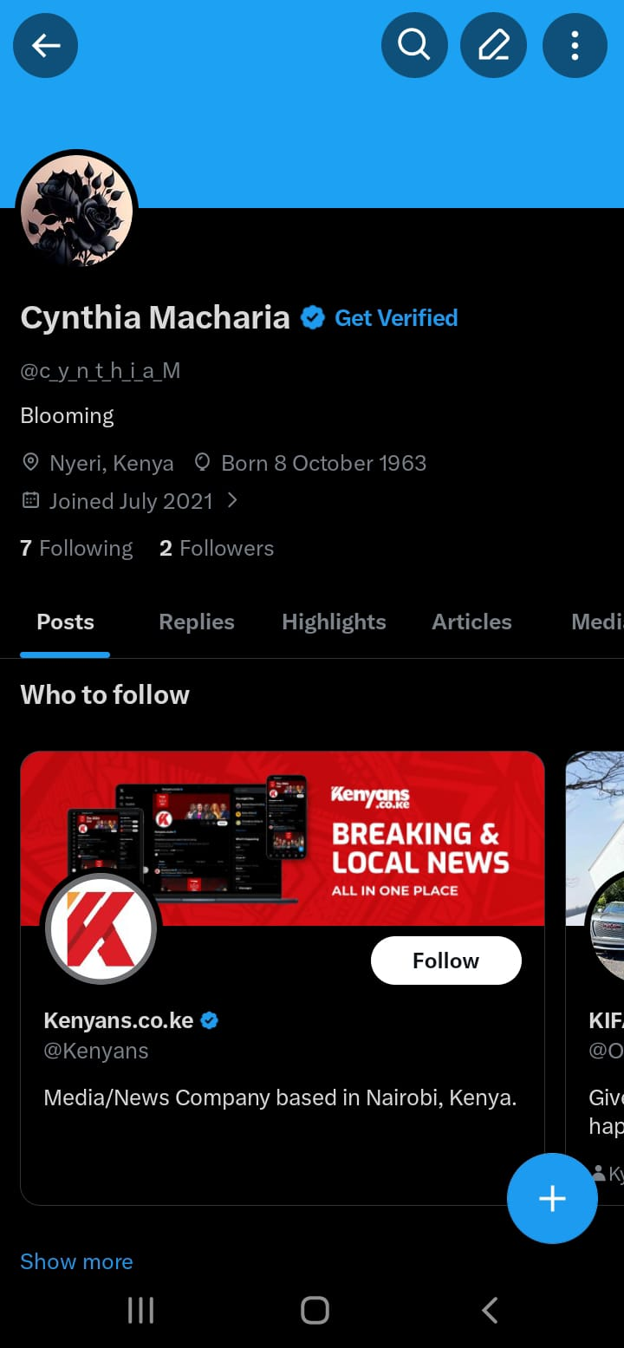

INSTAGRAM
https://www.instagram.com/cynthia_macharia?utm_source=qr&igsh=d2JybzNvOTBrdnRs

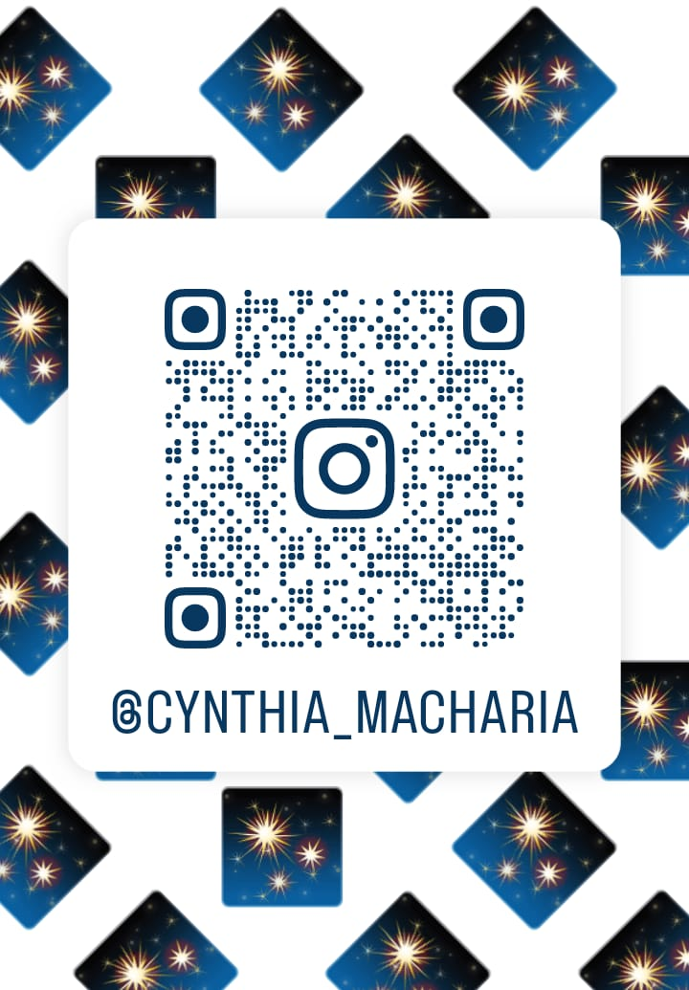

FACEBOOK
https://www.facebook.com/profile.php?id=100072428730322&sfnsn=wa&mibextid=RUbZ1f

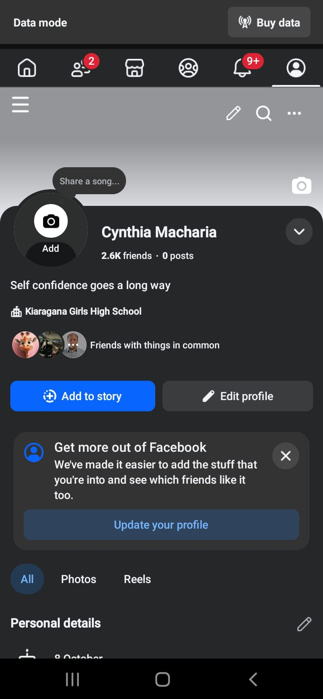

TIKTOK
https://www.tiktok.com/@cynthia_macharia8?_r=1&_t=ZS-93MUCOFRaML

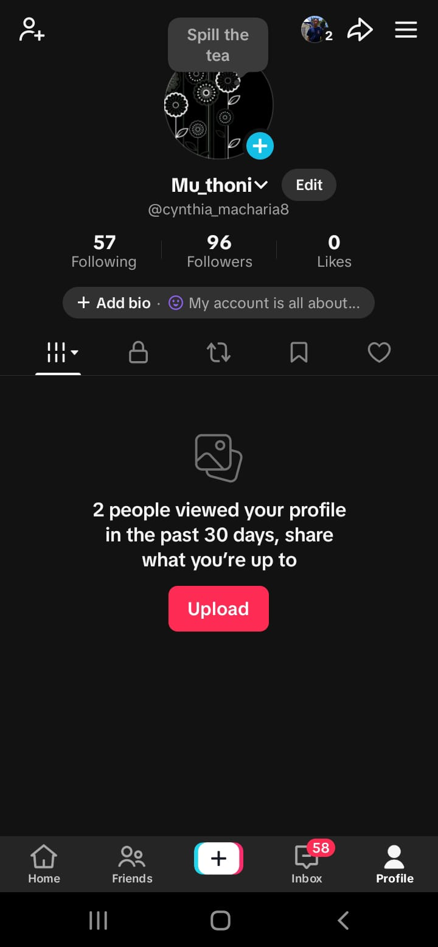

THREADS
https://www.threads.com/@cynthia_macharia

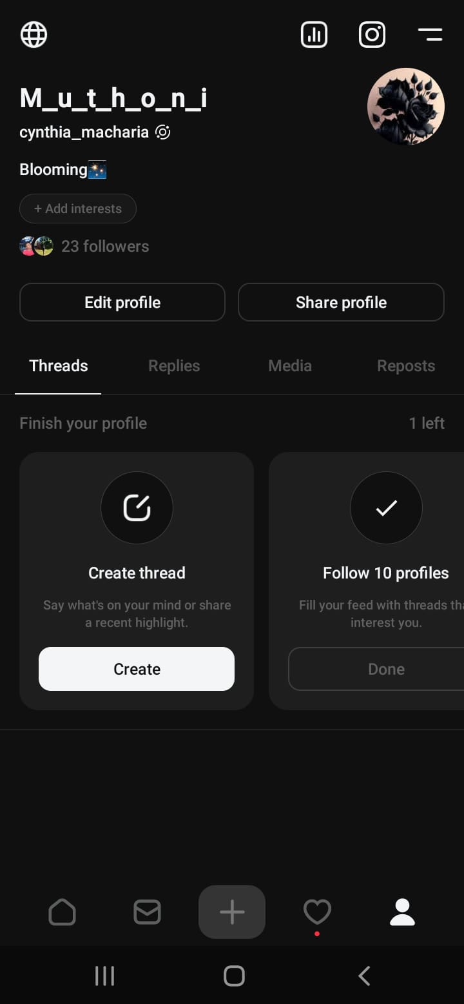

WHATSAPP
https://wa.me/qr/6P6NU6GNDPKDO1

